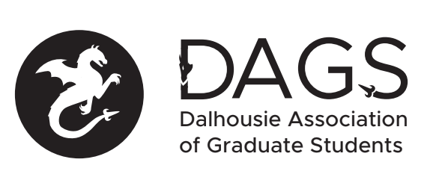

Local 113 of the Canadian Federation of Students
Council Meeting: Tuesday November 2nd 3:00 PM via Microsoft Teams
- CALL TO ORDER
- APPROVAL OF SECRETARY
- PRESENT
- APPROVAL OF AGENDA
- APPROVAL OF PREVIOUS DAGS COUNCIL MEETING MINUTES
- OLD BUSINESS
- NEW BUSINESS
  - DAGS Executive Updates
  - DSU Graduate Rep Updates
  - DAGS By-Election Timeline
  - Grant Approvals:
    - Brenna Sobanski
    - Courtney Henry
    - Karen Tang
    - Sareen Singh
    - Julia Koppernaes
    - Farzaneh Hamedi Azad
    - Merhnoosh Mohammadi
    - Krista Collier-Jarvis
  - Senate Caucus Updates
  - Faculty Council EDI and Academic Appeals Positions Available
- ANNOUNCEMENTS
- ADJOURNMENT
Minutes approved at meeting date: ______________
Moved by:____________
Seconded by:_____________

