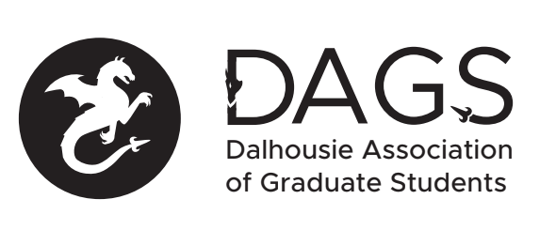

Local 113 of the Canadian Federation of Students
Council Meeting: Tuesday December 21st 3:00 PM via Microsoft Teams
- CALL TO ORDER
- APPROVAL OF SECRETARY
- PRESENT
- APPROVAL OF AGENDA
- APPROVAL OF PREVIOUS DAGS COUNCIL MEETING MINUTES
- OLD BUSINESS
  - DAGS Council Appointments
- NEW BUSINESS
  - DAGS Executive Updates
  - DAGS Executive Honoraria
  - DSU Graduate Rep Updates
  - Senate Caucus Updates
  - Grant Approvals
    - Karen Tang
    - Tareq Yousef & Delaney Henderson
  - DAGS Payroll System
- ANNOUNCEMENTS
  - DAGS AGM
- ADJOURNMENT
Minutes approved at meeting date: ______________
Moved by:____________
Seconded by:_____________

