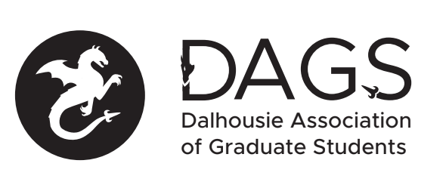

Local 113 of the Canadian Federation of Students
Council Meeting: Thursday January 27th 2:00 PM via Microsoft Teams
- CALL TO ORDER
- APPROVAL OF SECRETARY
- PRESENT
- APPROVAL OF AGENDA
- APPROVAL OF PREVIOUS DAGS COUNCIL MEETING MINUTES
- OLD BUSINESS
  - Online Banking issue
- NEW BUSINESS
  - DAGS Executive Updates
  - DAGS Executive Honoraria
  - DSU position elections or appointments
  - DAGS Elections
  - DAGS AGM
  - Grant Approvals
    - Nicole Doria
    - Maziar Rastmanesh
- ANNOUNCEMENTS
- ADJOURNMENT
Minutes approved at meeting date: ______________
Moved by:____________
Seconded by:_____________

