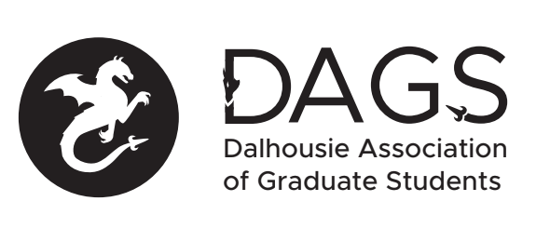

Local 113 of the Canadian Federation of Students
Council Meeting: Thursday January 27th 2:00 PM via Microsoft Teams
- CALL TO ORDER 2:08 PM
Fallen volunteers to Chair
- APPROVAL OF SECRETARY
Tiffany volunteers to take minutes (Fallen/Gabriella)
- PRESENT:
Fallen Matthews (VP Student Life and Communications)
Hariprashanth Deivasigamani (VP Academic)
Maria (Biomed Engineering Grad Students society)
Kathleen (Chemistry Grad Students society)
Alireza Ghadamagahi (DAGS Director of Architecture, Planning, and Engineering)
Cameron (Grad Physics society)
Pooyan Moradi (Director, Health and Medical Sciences)
Mohammad Ramezani (VP Financial Operations)
Ellen (Grad English Society)
Tiffany Campbell (interim VP External Advocacy)

- APPROVAL OF AGENDA (Fallen/Mohammed)
- APPROVAL OF PREVIOUS DAGS COUNCIL MEETING MINUTES (Fallen/Mohammed)
- OLD BUSINESS
  - Online Banking issue (Mohammad)
    - Mohammad, Fallen and Hari went to the bank of NS to get the DAGS bank account signing authorities adjusted, but the process is not fast enough (need to fill form) to do upcoming transactions in time. Mohammad is speaking with a bank Advisor- the process takes a couple of business days, but in the meantime, they will be able to help.
- NEW BUSINESS
  - DAGS Executive Updates
    - Mohammed: see above.
    - Fallen: Still with CUPE 3912, representing the workers on the Studley campus. They have been bargaining and attending various modules and workshops. Recommends that folks keep informed through the regular emails. Also, the DAGS office is still accessible, through the front desk.
    - Hari: Could not attend FGS Council.
    - Tiffany: Reached out to the previous VPE, but hasn’t heard back yet.
    - Ali: doesn’t have any updates
  - DAGS Executive Honoraria (Hari):
    - Payment for office coordinator and the honoraria- these two transactions are a priority.
  - DSU position elections or appointments
    - See DAGS website for current position vacancies, and anyone interested can get in touch via DAGS email.
  - DAGS Elections
    - Hari: We need to appoint a CRO who can oversee the DAGS election
    - Shauna: can send out an email requesting nominations for CRO
    - Tiffany: Do we have a timeline?
    - Hari: we can request DSU help us publicize our next elections.
    - Fallen: the CRO is supposed to be responsible for coordinating (sending out a formal request to get all of the grad student emails and program things in brightspace).
    - Shauna: elections happen between Feb 1st and March 31st of each year.
    - Fallen: we should get going on this then.
  - DAGS AGM
    - Last month AGM didn’t happen. We can afford to hold off because there isn’t a lot to report and because of covid closures, it’ll be a bit of a bummer (it’s usually catered).
    - Should it be during or after the election period?
  - Grant Approvals
    - Nicole Doria
    - Maziar Rastmanesh
    - Ryan Trendyle
    - Connor Acton
      - Motion to approve grants (Fallen/Tiffany)
- ANNOUNCEMENTS
- MOTION TO ADJOURN (Fallen/Ali)
Minutes approved at meeting date: ______________
Moved by:____________
Seconded by:_____________

