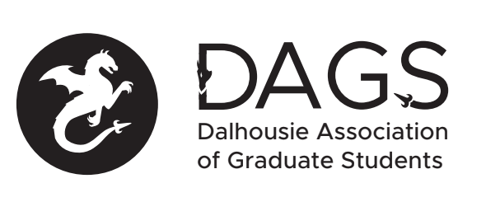

Local 113 of the Canadian Federation of Students
Council Meeting: Friday May 27th 5:00 PM, In-Person/Microsoft Teams
- CALL TO ORDER
- APPROVAL OF SECRETARY
- PRESENT
- APPROVAL OF AGENDA
- APPROVAL OF PREVIOUS DAGS COUNCIL MEETING MINUTES
- OLD BUSINESS
  - Community Representative positions - Discuss forming an interim ad-hoc committee and sending out an official call for applications
  - DAGS DSU Representative 2022/2023 position - application received from Aswini Anand
- NEW BUSINESS
  - DAGS Executive Updates
  - DAGS Executive Transition
  - Director of Health and Medical Science application received from Beatrice Chang. Discuss whether to hold by-election or to appoint vacant positions (vote to proceed with appointments must pass with ⅔ majority).
  - Possible second AGM to be held in late summer to ratify Governance Committee suggested revisions to constitution and bylaws
  - Discuss DAGS council meeting dates and times for this term
  - Grant Approvals
    - Arvin Vaziry (Travel and Professional Development Grants)
    - Anas Abufardeh
    - Nina Golombek
    - Julia Rodgers
    - Katia Stapleton
    - Society Grant - Physiotherapy Student Society (PTSS)
- ANNOUNCEMENTS
- ADJOURNMENT
Minutes approved at meeting date: ______________
Moved by:____________
Seconded by:_____________

