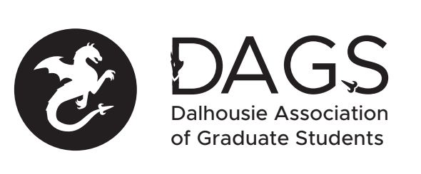

Local 113 of the Canadian Federation of Students
Council Meeting: Thursday, February 28th at 5:30 PM – DAGS Office– SUB, 4th Floor
- CALL TO ORDER:
- Present:
- APPROVAL OF AGENDA
  - Motion to be approved: (18-EXEC-102)
- APPROVAL OF MINUTES (Jan 17 and 31)) – (18-EXEC-103)
- PRESENTATIONS AND CORRESPONDENCE
  - Iranian Student Association
- NEW BUSINESS
  - Grants approval
  - AGM
    - By-laws
    - Budget
- ANNOUNCEMENTS
  - DAGS AGM – March 7th at 5:30pm
  - DAGS Election Timeline – March 7th (Nominations launch) – April 3rd (Voting End)
- ADJOURNMENT
Minutes approved at meeting date: ______________
Moved by:____________
Seconded by:_____________

