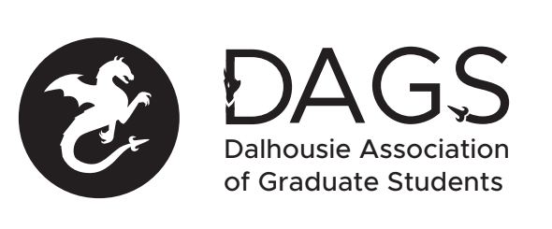

Local 113 of the Canadian Federation of Students
Council Meeting: Friday, June 26th at 3:00 PM – Via Microsoft Teams
- CALL TO ORDER
- APPROVAL OF SECRETARY
- PRESENT
- APPROVAL OF AGENDA
- APPROVAL OF MINUTES (May 26th)
- OLD BUSINESS
  - Election Update
- NEW BUSINESS
  - COVID-19 Grant
- ANNOUNCEMENTS
  - Ratification Update
- ADJOURNMENT
Minutes approved at meeting date: ______________
Moved by:____________
Seconded by:_____________

